《数据库概论》 实验二 用户自定义完整性约束 实验报告

吴政亿 151220129 18805156360@163.com

实验环境

Windows 10 ，mysql- community-5.7.20.0

实验过程

**实验截图**

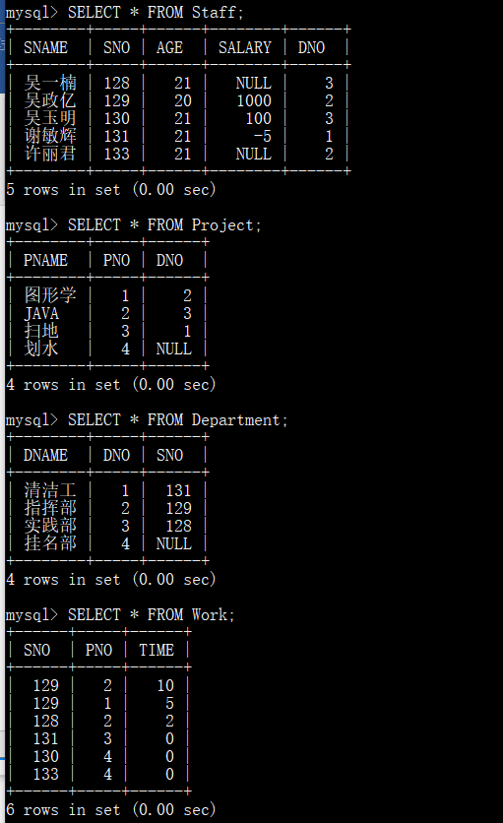

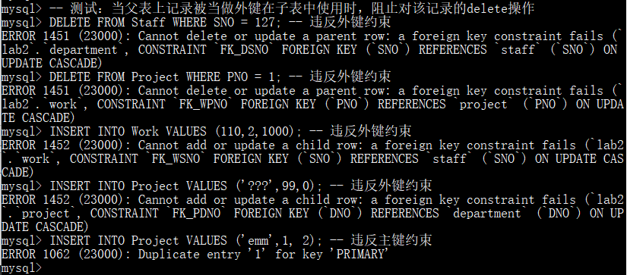

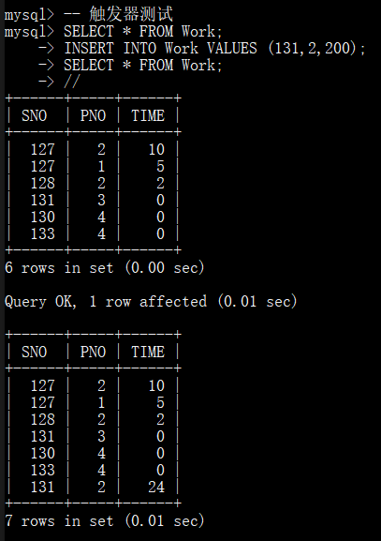

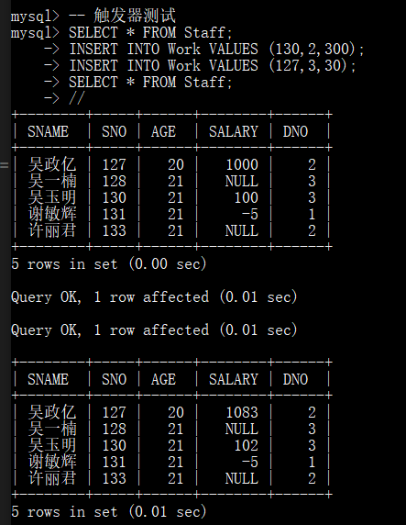

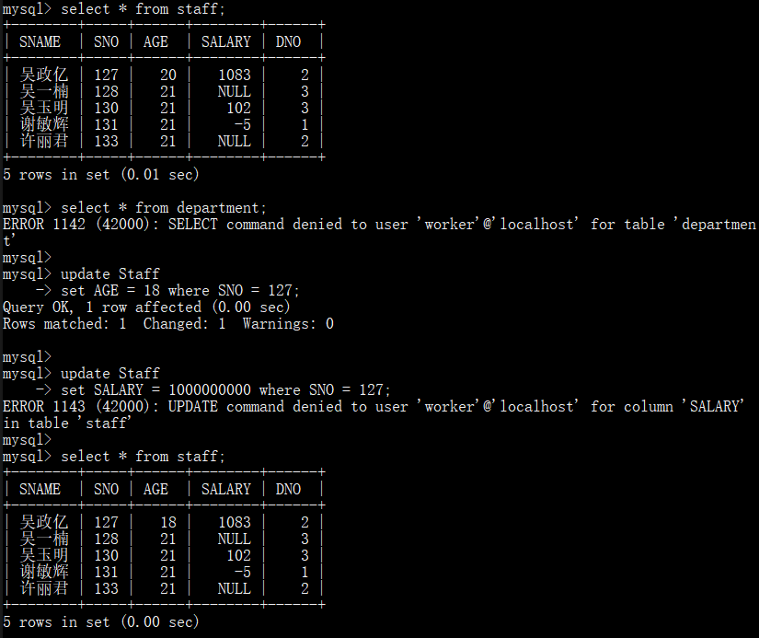

实验代码

CREATE DATABASE lab2;

USE lab2;

/*

职工 staff

姓名 sname

工号 sno

年龄 age

年薪 salary

部门编号 dno

*/

CREATE TABLE Staff

(

SNAME char(8) NOT NULL,

SNO int NOT NULL,

AGE int DEFAULT 0, -- 默认值约束

SALARY int,

DNO int, -- FOREIGN KEY REFERENCES Department(DNO) --外键约束，之后再加

PRIMARY KEY (SNO)

);

/*

部门 department

部门名称 dname

部门编号 dno

部门负责人工号 sno

*/

CREATE TABLE Department

(

DNAME char(8) NOT NULL,

DNO int NOT NULL,

SNO int, -- FOREIGN KEY REFERENCES Staff(SNO) -- 外键约束，之后再加

PRIMARY KEY (DNO)

);

/*

项目 project

项目名称 pname

项目编号 pno

主管部门编号 dno

*/

CREATE TABLE Project

(

PNAME char(8) NOT NULL,

PNO int NOT NULL,

DNO int,

PRIMARY KEY (PNO)

);

/*

工作 work

职工工号 sno

项目编号 pno

工作时间 time

*/

CREATE TABLE Work

(

SNO int,

PNO int NOT NULL,

TIME int DEFAULT 0 -- 默认值约束

);

INSERT INTO Staff

VALUES

('谢敏辉',131,21,-5,1),

('吴政亿',129,20,1000,2),

('吴玉明',130,21,100,3);

INSERT INTO Staff(SNAME,SNO,AGE,DNO)

VALUES

('吴一楠',128,21,3),

('许丽君',133,21,2);

INSERT INTO Department

VALUES

('清洁工',1,131),

('指挥部',2,129),

('实践部',3,128);

INSERT INTO Department(DNAME,DNO)

VALUES

('挂名部',4);

INSERT INTO Project

VALUES

('图形学',1,2),

('JAVA',2,3),

('扫地',3,1);

INSERT INTO Project(PNAME,PNO)

VALUES

('划水',4);

INSERT INTO Work

VALUES

(129,2,10),

(129,1,5),

(128,2,2);

INSERT INTO Work(SNO,PNO)

VALUES

(131,3),

(130,4),

(133,4);

-- 1

SELECT * FROM Staff;

SELECT * FROM Project;

SELECT * FROM Department;

SELECT * FROM Work;

alter table Department

add constraint FK_DSNO

foreign key (SNO)

references Staff(SNO)

ON UPDATE CASCADE;

alter table Project

add constraint FK_PDNO

foreign key (DNO)

references Department(DNO)

ON UPDATE CASCADE;

alter table Work

add constraint FK_WSNO

foreign key (SNO)

references Staff(SNO)

ON UPDATE CASCADE;

alter table Work

add constraint FK_WPNO

foreign key (PNO)

references Project(PNO)

ON UPDATE CASCADE;

-- 测试：在父表上update记录时，同步update子表上外键的值

update Staff

set SNO = 127 where SNO=129;

-- 测试：当父表上记录被当做外键在子表中使用时，阻止对该记录的delete操作

DELETE FROM Staff WHERE SNO = 127; -- 违反外键约束

DELETE FROM Project WHERE PNO = 1; -- 违反外键约束

INSERT INTO Work VALUES (110,2,1000); -- 违反外键约束

INSERT INTO Project VALUES ('???',99,0); -- 违反外键约束

INSERT INTO Project VALUES ('emm',1, 2); -- 违反主键约束

delimiter //

CREATE TRIGGER TG_Time

BEFORE INSERT ON Work

FOR EACH ROW

begin

if NEW.Time > 24 then

set NEW.Time = 24;

end if;

end;

//

-- 触发器测试

SELECT * FROM Work;

INSERT INTO Work VALUES (131,2,200);

SELECT * FROM Work;

//

CREATE TRIGGER TG_salary

AFTER INSERT ON Work

FOR EACH ROW

begin

update Staff set salary = salary*1.02 where SNO=NEW.SNO;

update Staff set salary = salary*1.03 where

SNO = any(SELECT SNO FROM Department);

end;

//

-- 触发器测试

SELECT * FROM Staff;

INSERT INTO Work VALUES (130,2,300);

INSERT INTO Work VALUES (127,3,30);

SELECT * FROM Staff;

//

delimiter ;

CREATE USER 'worker'@'localhost' IDENTIFIED BY '123456';

GRANT SELECT ON lab2.Staff TO 'worker'@'localhost';

GRANT UPDATE(AGE) ON lab2.Staff TO 'worker'@'localhost';

-- 下面进入worker

exit;

mysql -uworker -p123456

use lab2;

select * from staff;

select * from department;

update Staff

set AGE = 18 where SNO = 127;

update Staff

set SALARY = 1000000000 where SNO = 127;

select * from staff;

-- 下面返回root

exit;

mysql -uroot -pwuzhengyi

DROP USER 'worker'@'localhost';

DROP DATABASE lab2;

实验中遇到的困难及解决办法

本次实验中在触发器设计时一直报错，之后发现了时在after的情况下update导致的反复调用。

参考文献及致谢

http://www.w3school.com.cn/sql/index.asp

这个网页教程很全啊